Note: Include this page only when adding / amending / deleting a document. If using this document as a record, this Revision History page can be omitted.

REVISION HISTORY

Revision no | Date | Description of Changes | Reason for Revision | Revised by | Approved By
1 | 10 Apr 2012 | Add revision history page  Add some notes for timesheets | Recommendation from Stage 2 audit | RDPlacido  WRRobles
2 | 02 July 2014 | Add References | In response to CPIAR 2014-365 & 2014-412 | WRRobles
3 | Apr. 8, 2016 | Added disclaimer when printing the document | For document control | RCGanal | WRRobles
TM-BR-MG- 11 Rev02, 10302015

- Objective
To ensure that salaries and benefits of the employees are paid accurately & completely on or before the 10th and 25th of the month.

- Scope

This procedure defines the actions and responsibilities of Payroll Accountant, AP Accountant and Finance Head in payroll procedure. This covers activities from receiving of timesheets to release of payroll to employees.

- Definition of Terms
Employee file | A file in the MSI Payroll System which is the receiving point for data entry of an employee and maintenance field for updates
Payroll Register | A detailed list of earnings and deductions of employees arranged in alphabetical order
Headcount | A table showing total number of employees per payroll category for a given payroll period

- Procedure Details
RESPONSIBLE | ACTIVITY | INTERFACE
Payroll Accountant  Finance Head | 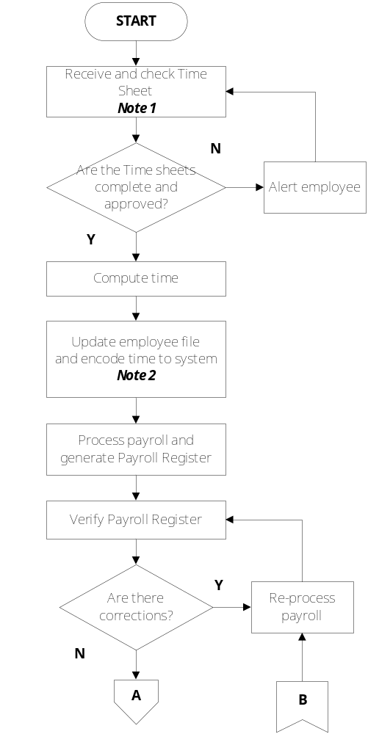 | Employee/Account Manager/Supervisor  Employee/Account Manager/Approving Authorities  GL-FI-FI-02  MSI Payroll System  GD-FI-FI-01  GD-FI-FI-02  Payroll Register  Payroll Accountant

RESPONSIBLE | ACTIVITY | INTERFACE
Payroll Accountant  Finance Head  Finance Head  President & VP  Payroll Accountant/Finance Head | 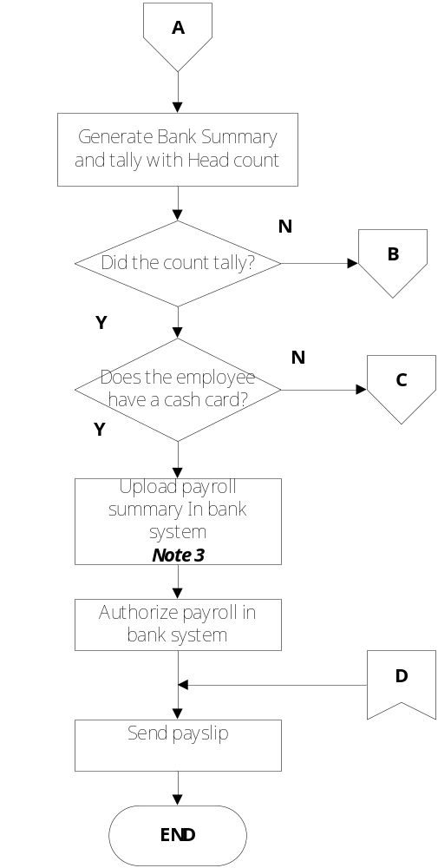 | Bank Summary/Headcount  Payroll Register  Bank Summary

RESPONSIBLE | ACTIVITY | INTERFACE
Payroll Accountant | 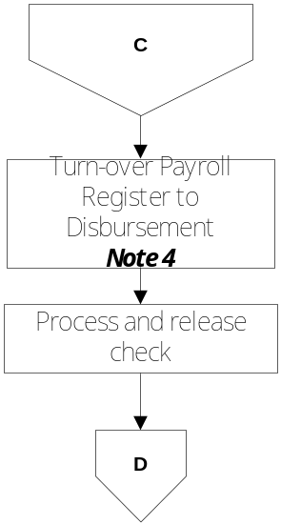 | AP Accountant

Notes:
- The NO TIMESHEET, NO PAYROLL policy shall be strictly enforced.
- Timesheets, overtime notice and leave form shall be signed approved by immediate superior.
- Timesheets submitted on time but no approval yet from for reasons beyond the control of the concerned employees shall be included in the payroll process but overtime payment shall be deferred. When approved timesheet is subsequently received, overtime shall be paid on the next payroll date.
- Employees without BDO cash card are paid through check.
- Employees with BDO cash card are uploaded in the bank system through the Corporate Internet Banking.
- Update Employee File in the payroll system using the New Hires & Movement Register.
- References:
- GD-FI-FI 01 Guidelines in Updating Employee Files on the Payroll System
- GD-FI-FI 02 Guidelines in Payroll Computation
- GD-FI-FI 10 Guidelines on Payroll Process & Release
- WI-FI-FI 02 Manual of Instruction for Using DA-800 Biometrix System
- Employee & Salary Movements Register.xls
- 201 Files

- Quality Records
- Bank Summary (system generated)
- Payroll Register (system generated)
- Timesheets, OT Notice, Leave form, Reimbursement Form
- Request for Trainor’s Allowance
- Headcount of Employees
- Leave Monitoring for Regular, Staff, PL 5&6.xls
- VL/SL.xls
- Additional Compensation Income

